Thame Town Council: Public Art Strategy & Plan
- Background

Thame has been awarded Public Arts Funding through Section 106 agreements in light of new building developments around town. In November 2017, The Town Centre Working Group formed a sub Public Arts Working Group to write this strategy. The strategy was approved at the Neighbourhood Plan Continuity Committee meeting on Tuesday 25 September 2018.
- Definition of public art
Planning Policy Guidelines state "Public art and sculpture can play an important role in making interesting and exciting places that people enjoy using". The National Planning Policy Framework definition of Public Art is that it should "Take Account of and support local strategies to improve health, social and cultural wellbeing for all, and deliver sufficient community and cultural facilities and services to meet local needs".
While public art can include the more traditional idea of a sculpture it can also encompass a wide range of features, for example:
- Specialist treatment of some aspects of a building - stained glasswork, mosaics, floor/wall design, lighting or timberwork
- Provision of hard or soft landscaping, paving, gates, arches, seating, play areas and bridges
- Interpretation of a specific site or place
- Provision of space for artistic use
- Major landmark or urban design features
Where Public Art is physical in nature, it must always be publicly visible and, in line with South Oxfordshire District Council’s definition, ‘be made by a professional artist, is bespoke and of high quality’.
Public art can be temporary or permanent in nature and, as part of an overall programme, consideration can be given to extend the definition of Public Art to include temporary events festivals and activities or temporary installations.
- The value of public art

When considering Public Art in Thame the following values are to be upheld.

All public Art in Thame should:
- Enrich Thame’s unique identity
- Create a sense of place for both residents and visitors to Thame
- Develop the physical environment by adding interest, quality and distinctiveness
- Provide a source of pride among the community
- Add to the enjoyment and interest of local people and visitors
- Make existing public spaces more comfortable, relaxing, meaningful and attractive to meet in

Individual pieces of art may also:
- Integrate new developments into the existing townscape, creating bonds within the area and developing a sense of belonging
- Celebrate our local communities creativity, and empower the evolution of this existing creative community
- Get the local community involved in art, helping to stimulate debate, ignite passion and discussion and generate excitement
- Provide a legacy for the future - creating tomorrow’s heritage
- Celebrate Thame’s heritage: raising awareness of our history
- Aid in local orientation through landmarks or through being part of a Wayfinding solution
- Improve the Economy by providing employment for artists and craftspeople, and increasing tourism by acting as a landmark or attraction.
- Contribute to individual personal development, imagination and vision, enabling personal development and encouraging well-being, aspirations and equality
- Provide employment for local artists and craftspeople

- Aims of the Strategy

This Strategy aims to ensure that the potential benefits of increased public art activity are maximised for Thame and its population by
- Enabling a coordinated approach to the use of this money across the parish
- Ensuring that all projects are integrated into the development of the town as a whole
- Working in partnership with the community, public and private sectors
- Creating work of high quality: work which is durable and easy to maintain and which integrates with the functional requirements of the immediate area.
- Promoting a role for local, regional, national and international artists
- Maximising resources for the commissioning of artists
- Identifying and implementing good commissioning practices

- Current resources

  - SODC Arts Development team
South Oxfordshire District Council, as the planning authority, has main responsibility for encouragement, implementation and enforcement of the Public Art obligations through the planning process. This will also include granting Planning Permission for public works of art themselves. The Arts Development Officer works on many different projects throughout the district, across different art forms and many different communities, although retains a specialism in Public Art Commissioning.

  - Public Art Working Group (PAWG)
In order to achieve genuine local dialogue about the development of Public Art in Thame, a Public Art Working Group was established in November 2017 with the SODC Arts team as well as members of the community being invited to participate. The group’s members are:
- Cllr Mary Stiles, (Thame Town Council) - Chair
- Becky Reid, Market Town Coordinator, (Thame Town Council)
- Abigail Brown, (SODC Arts Team)
- Lin Wylie, (21st Century Thame representative)
- Phil Williams & Jill Hind, (Thame Museum Archaeological Group)
- Christine Tacq, (Local artist, founder of Sparksartists and coordinator of The Big Draw)
- Susannah Fellows, (Owner of ‘fitch & fellows’ gallery and shop)
- Fiona Buszard, (Local resident & Art Director for a Greeting Card company)
- Jackie Nichols, (Teacher and lead on Art Weeks at John Hampden School)

The current roles of the steering group are to:
- Develop this Public Arts Strategy
- Identify locations and opportunities
- Write artistic briefs
- Shortlist appropriate artists
- Connect and engage the community in the process where appropriate
- Help to promote and celebrate the works of art
- Identifying resources for future development of Public Art, outside of Section 106 and CIL funding (such as Arts Council funding)

  - Town Centre Working Group (TCWG)

The TCWG is the parent group of the PAWG. This group is responsible for
- Reviewing and approving the detailed briefs created by the PAWG for each piece of Public Art
- Convening and appropriate selection panel who will interview and commission artists (who have first been shortlisted by the PAWG) to take the lead on each piece of Public Art.

  - Funding available

There are currently 6 developments in the parish that have committed to Public Art contributions. Each commitment contains its own restrictions and these will need to be considered when developing briefs to commission artists.

Site | Developer | Amount | Status/Restrictions
Site C: Thame Park | Taylor Wimpey | £21,031.86 | PAID
Site C | Bellway | £28,820.77 | Due on 75th dwelling – ‘Public art in Thame’
Site D | Persimmon | £35,000.00 | Due on 125th dwelling – ‘public art in Thame’
Site F: Thame Meadow | Bloor Homes | £47,106 (£7,066 towards maintenance) | Due on 75th dwelling – directional signage and information boards on footways around Thame
Park Street: Seymour Court |  | £4641.03 (£696.15 towards maintenance) | When first dwelling is occupied - ‘public art within Thame town centre’
The Elms | Rectory Homes | £9,873 (£1,287 towards maintenance) | Due on 20th dwelling – ‘public art provision at The Elms Recreation Ground or The Elms Site’

- Current public art in Thame
Thame has a number of public artworks already in place. These are:
Thame Cows: A herd of cows was created as an historical reminder to residents and visitors that Thame was originally a market town. They also provide an interesting placed on billboards hung around the cows’ necks. The aim was to use them to promote up and coming events, such as festivals and shows. The cows were the idea of town partnership 21st Century Thame, and was funded from rural grant programme LEADER, matched by South Oxfordshire District Council.’ | 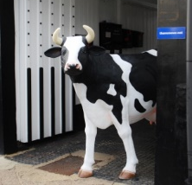
COLOUR SPACES, Claude Heath, Cotmore Business Park,
The public art project comprised a sculpture on the frontage of the business park together with a programme of public engagement. The starting point for the commission was to develop the sculptural equivalent of colour space. “In the digital age, all colours have three numbers to show their mix of red, green, and blue. Now try to imagine a three dimensional space in which any colour can have its location pinpointed, each of the three numbers helping to place it spatially. If each colour has a height, width, and depth, then you can imagine that all the colours in a picture, for example, will combine to form a colour space, a spatial field of colour that contains all of them. It is also possible to take one further step, imaginatively speaking, taking a colour space and giving it a solid form, as a painted sculpture that will stand on the grass beside an Oxfordshire byway, a spectrum in tangible shape to act as a beacon and conductor of colour in its surroundings.” Claude Heath
The Phoenix Trail:  This comprises a series of 30 artworks sited over 5 miles between Thame and Princes Risborough. It was inspired by the old railway environment and the landscape looking out to the Chiltern Hills.The project was a partnership between Sustrans, Rycotewood College, The Arts Council, Ercol Furniture Ltd, the Transnational Woodlands Industries Group, Arts & Business and Wycombe and South Oxfordshire District Councils. Lead artist Angus Ross together with six furniture students from Rycotewood College in Thame made sculptures and distinctive resting places using mainly green oak, locally sourced from the Chilterns.  Lucy Casson was commissioned to make copper characters on poles. Lucy also ran educational projects at John Hampden and Princes Risborough schools. The project was an overwhelming success in many respects, reflected in the fact that it succeeded in winning the 2002 'Arts, Business & Community' Award from Arts & Business. | 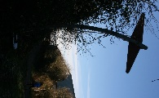  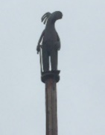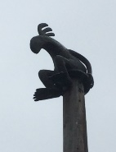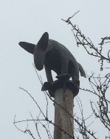
Thame Youth Memorial: The Youth Memorial is located next to the Memorial Gardens in the Upper High Street. The design was based on concepts of Infinity and Reflection, and evolved, through the generous efforts, over many months, of a number of local designers and the Youth Memorial Supporters group. | 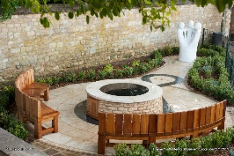
The Millennium Planter: This planter is located on the ‘Millenium Circle’, which itself was created in 1999 to mark the Millennium. It took a further 13 years to decide what should go on the circle. During this time there was a lot of discussion and debate and a competition that did not result in an idea that was acceptable or affordable. In the end Thame Town Council decided to install the circular seat with the aim of giving the area a strong identity similar to that of the Buttermarket and Swan Walk, and to prevent people parking on top of the circle. Funding for the planter-seat came from South Oxfordshire District Council’s Town and Larger Villages Infrastructure Fun | 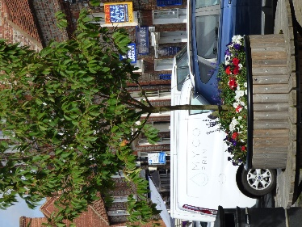
War Memorial  This memorial was established in 1920 and commemorates the residents of Thame who were killed or missing in the First World War (94 names) and the Second World War (22 names) | 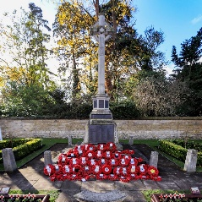
Memorial Gardens: Located next to the war memorial, the Pearce (local woolstaplers) Memorial Gardens contains a fountain and a statue of a boy positioned over two fish ponds. The original statue was erected in 1926 by Ernest Pearce of Australia as a monument to the memory of his parents Philip Henry Pearce and his wife Elizabeth. The bronze fountain statue was stolen in September 1985 and was never recovered. In the summer of 1992, a replica of the original statue was commissioned by the Town Council. | 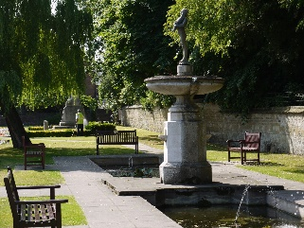
Band Stand  This bandstand is located in private property off Church Road. The Bandstand moved from Halton House, Aylesbury where it was owned by Lord Rothschild. | 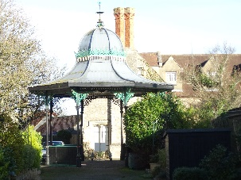
Pencils:
This Pencils Sculpture is at Lord Williams's Lower School in the playground outside the art rooms. It is a kinetic sculpture in steel so the pencils move against each other in the breeze

Red Kite outside Soha Housing on Windmill Road. Paid for with public arts funding from the redevelopment of this site, the Kite is inspired by the large Kite population regularly found in the skies above Thame today. This bird, after it being hunted almost to extinction, was reintroduced in the mid-20th century to the Chilterns. | Need photo
Megans Bench  Designed and fundraised for by her friends, in memory of Megan Biddle, this unique bench was designed by Michael Gibbs | 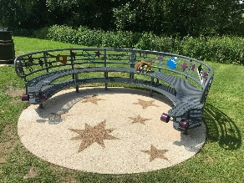
Lord Williams School: Ambitions are held for a piece of public Art at the Upper School. | To be designed

Arts Activities in Thame
As well as pieces of Public Art in Thame, there are several arts groups and events that already run. The change from Section 106 ‘Public Arts’ funding to CIL ‘Cultural Activities’ funding, will mean that projects are also eligible for funding, and this needs to be considered when developing this strategy.
Thame Arts & Literature Festival (TAL) | An annual festival held in October that focuses on all things literary, including Author Talks, Music, Literature, Plays, Readings, Debates and much more.
Big Draw | Founded in 2000, The Big Draw (formally The Campaign for Drawing) is an arts education charity that promotes visual literacy and the universal language of drawing as a tool for learning, expression and invention.  The charity leads a diversified programme encompassing advocacy, empowerment and engagement, and is the driving force behind the The Big Draw Festival – the world’s biggest celebration of drawing
Thame Art Crawl | An annual event run in conjuction with TAL, with pop-up arts venues hosting exhibitions throughout the town cetnre.
Thame Museum | Hosting regular Exhibitions of local artists througout the year
Oxfordshire & Buckinghamshire Arts Weeks | Open studios and diverse pop-up exhibitions in towns and venues across Oxfordshire, for free, run during May. Artweeks is the opportunity to see amazing art in wonderful places; meet artists in a wide range of interesting places, talk about their work, watch demonstrations and maybe have a go yourself. Including painting, photography, textiles, sculpture and ceramics, to furniture, glass, mosaics, jewellery, digital art and more.
Sparksartists | Sparksartists was formed in 2001 to "combat isolation of visual artists in the region. Promote, maintain, and improve public awareness of the arts." They have in common a commitment to working as individual visual artists but also have a desire to collaborate and share ideas and experiences in a variety of areas of community arts". The group organises 'Art Café' a monthly discussion arts sharing group held at Rumseys café for anyone who feels like turning up

- Thame’s Characteristics & potential themes

There are a number of features which make Thame distinctive and contribute to its identity. These features provide a context and inspiration for public art, and should be considered as potential themes when developing artist’s briefs for commissioning
History & Heritage: Thame appears in history text books as a well-preserved example of a medieval planned town and will shortly appear as a market town with 6 thousand years of continuous history. Markets remain a strong part of Thame’s identity with 3 regular markets taking place in Thame - Cattle Market, Tuesday Charter Market & Farmers Market – as well as many pop-up markets. Throughout the town are sites of interest that contribute to the story of Thame’s rich history. Some areas that are currently being developed have specific historical and archaeological significance and Public art on these sites should consider how it can increase awareness of these factors. Thame has a history of interesting events that could also be influential in developing Public Art
People/ inventions/ events in Thame’s history: Throughout Thame’s history and up until the present day there have been noteworthy individuals, activities and inventions connected to Thame. Individuals have included Alfredo Campoli the very successful violin soloist; Henry Boddington the Brewer; James Figg, England’s first bare knuckle boxer; John Fothergill the hotelier who wrote ‘Diary of an InnKeeper’; John Hampden the parliamentarian; W B Yeats the poet; Herbert Norris: lived in Godbegot (Tudor building looking over the Cricket Field). He was a Theatrical set designer for the West end and the Shakespeare company; Victoria Pendleton currently lives in Moreton; Robin Gibbs lived in The Prebendal and is buried in St Mary’s Churchyard; Howard Goodle and often Rowan Atkinson et al used to meet in the cottage to brainstorm ‘Not the 9 0’clock news’. There are many more. Thame saw the creation of the foil caps on the top of milk bottles; the ‘Hook & eye’. Interesting events included the 1913 visit from Oldham Great Pilgrimage of Suffragettes who camped on the Rec; a Viking long ship passing through Thame in 1949 journeying from the North Sea to Pegwell. "Farmer Giles of Ham" a comic Medieval fable written by J. R. R. Tolkien in 1937 and published in 1949 is based in Thame.
Built environment - There are a number of features which make a unique contribution to Thame’s built environment. The town centre falls within a conservation area, hosting a range of beautiful, historic buildings; the boat shaped High Street with a central market place narrowing for toll gates to count cattle; Burgage Plots: long thin strips running off Cornmarket that formed a core part of the towns development. Plans for Public Art should include consideration of these features, and others, and how to enhance them. The new developments are situated on the outside of the town, some the outside of a Ring Road that originally contained the town. Plans for Public Art should consider how it can play a part in integrating these developments into the current townscape. There is limited public spaces in the town centre and Public Art could play a part in enhancing and improving those that do exist.
Link to Nature/ The Countryside: Thame has strong links to the countryside through its farming Heritage. Within Thame connections to nature can been seen in Cuttlebrook Nature Reserve (Cox’s Wood); Thame River/ Water Meadows; Elms Park; Southern Road Recreation Ground; The Phoenix Trail; War Memorial Gardens; Ham Wood; Thame Park; Cricket Ground; various allotment sites. Red Kites are a core feature in the skies above Thame. All of these can be considered when developing Public Art.
Festivals, Events and activities: Thame is a town of festivals, and major annual events include Thame Arts & Literature Festival; Music in the Park, Thame Town Music Festival; Thame Carnival; Towersey Festival; Thame Food Festival; Sports in the Streets; Christmas Lights Switch on. Thame also hosts many regular events with Thame Players Theatre, Thame Cinema 4 All. Thame Museum, Midsomer Murders connections, First Thursday music club, many venues hosting live music throughout the year and many more. Thame is a thriving community with regular Sports clubs, societies, and voluntary groups and arts activities such as those outlined in section 6. These various events offer opportunities for artists to create public art which explores relevant themes, leaves a lasting reference, or commemorates significant anniversaries.
Demographics: Thame’s Demographics also need to be considered in the development of Public Art. Population is increasing and more people are moving into the area, joining the families who have lived in Thame for many generations. There is low ethnic diversity. The population is ageing, but there are many families with young children attracted to Thame by the good schools. The 18 -24 year group is under-represented in population numbers. Employment rates are high. Education levels are high. Home ownership is high, but getting harder to achieve. Although the town is a wealthy one, there are pockets of deprivation. The town has an increasing number of commuters living in it, but there are those who don’t have a car and may spend most of their time in and around Thame

- Community involvement & Partnerships

It is essential that the community is included in the creation of Public Art. This could range from votes on designs, community events to help celebrate and unveil the works of art, to participatory activities with the selected artist/s or simply meeting and inspiring the artist with stories and local knowledge. The steering group will guide each project appropriately through the development of details briefs for each piece of work, being sure not to consult too much too early as some projects take years before results are seen. Where developments seek to commission public works of art before communities have moved in, post creation publicity will be important to enable greater understanding of the Public Art for new inhabitants.
It will also be important to build on relationships with developers of new estates as well as other relevant private and public sector parties, in addition to arts funding and development agencies. It is intended that the proposals for key projects outlined below will facilitate partnership work.
Following the successful installation of new pieces of Public Art around Thame, consideration will be given to the creation of an ‘Art Trail’ leaflet that encourages people to explore the art contained within the town.
- Commissioning

  - Commissioning practice
There are a range of commissioning practices that can be adopted, and the scale and location of the commission will be factors in determining the most appropriate process. However, there are some principles of good practice which should be considered when commissioning pieces of Public Art for Thame. These are:
- Each commission, however small, should be accompanied by an artist's brief which gives information on the aims of commission, site, budget, timescale and selection process
- The artist's brief should not be prescriptive, and should aim to foster rather than restrict the creativity and imagination of artists
- Where appropriate, artists should be commissioned at an early stage so that they are able to consider appropriate ways of involving the public, whether through consultation, exhibitions, education programmes, workshops, presentation or talks
- For each piece of work, a selection panel will be convened, including representatives from the Public Arts Working Group, South Oxfordshire District Council, Thame Town Council’s Town Centre Working Group, the developer whose funding is being used and any other stakeholders who have relevant link to the commission
- Thame-based artists working in the appropriate medium and with the appropriate experience should be considered as part of any selection process
- Commissioned artists should be issued with contractual agreements

  - Artists Briefs
All commissions, however small, should be accompanied by an artist’s brief which should aim to foster, rather than restrict, the creativity and imagination of the artist. The artist’s brief should include the following information:
- General description of the project
- Aims and objectives of the commission
- Description of the artist’s role
- Appointment procedure
- Details of PAWG team members, role and responsibilities
- Scope for the work; any themes, preferred materials or locations (and the implication on the need for lighting in relation to these locations)
- Planning requirements
- Consideration of risk and impact on local community and amenities
- Management arrangements/systems for the project, ensuring the implementation process is clear in each case
- Plans for community consultation and involvement
- Maintenance and durability, including maintenance processes and responsibilities beyond implementation
- Timetable
- Budget including contingency funds
- Artists copyright position and clarifications of ownership

  - Commissioning process

For each brief the following process will be followed:
Advertise for artist nationally and locally

Artists to be shortlisted by the Public Art Working Group
(research for the artist based on the site, location and any local contacts)

Artists to be interviewed and commissioned for design phase by an appropriate selection panel convened by the Town Centre Working Group. This will include one member of the SODC Arts Team, one member of the PAWG, one member of the TCWG and one relevant partner.

Artists might start to involve the community in the design stage and introduce their work and the project

Artist to present design options - often between one and four ideas to the selection panel. This will include a design statement, scale drawing and/ or models of proposals, timescale, fully costed budget and installation statement with suggested maintenance schedule

Sometimes at this stage (depending on how many designs are proposed) it is good to advertise and exhibit the proposals for public feedback.
Seek approvals such as planning permission, parish council and future owner of work

Commission design
Depending on what is proposed will depend on the nature and scale of the work

Unveil work
with community event and good publicity

- Identification of key projects
The Public Art Working Group has identified the following Public Arts projects in Thame to be delivered over the next 5 years, listed in priority. Each project is subject to funding availability, restrictions, terms & conditions and agreement from all relevant parties.
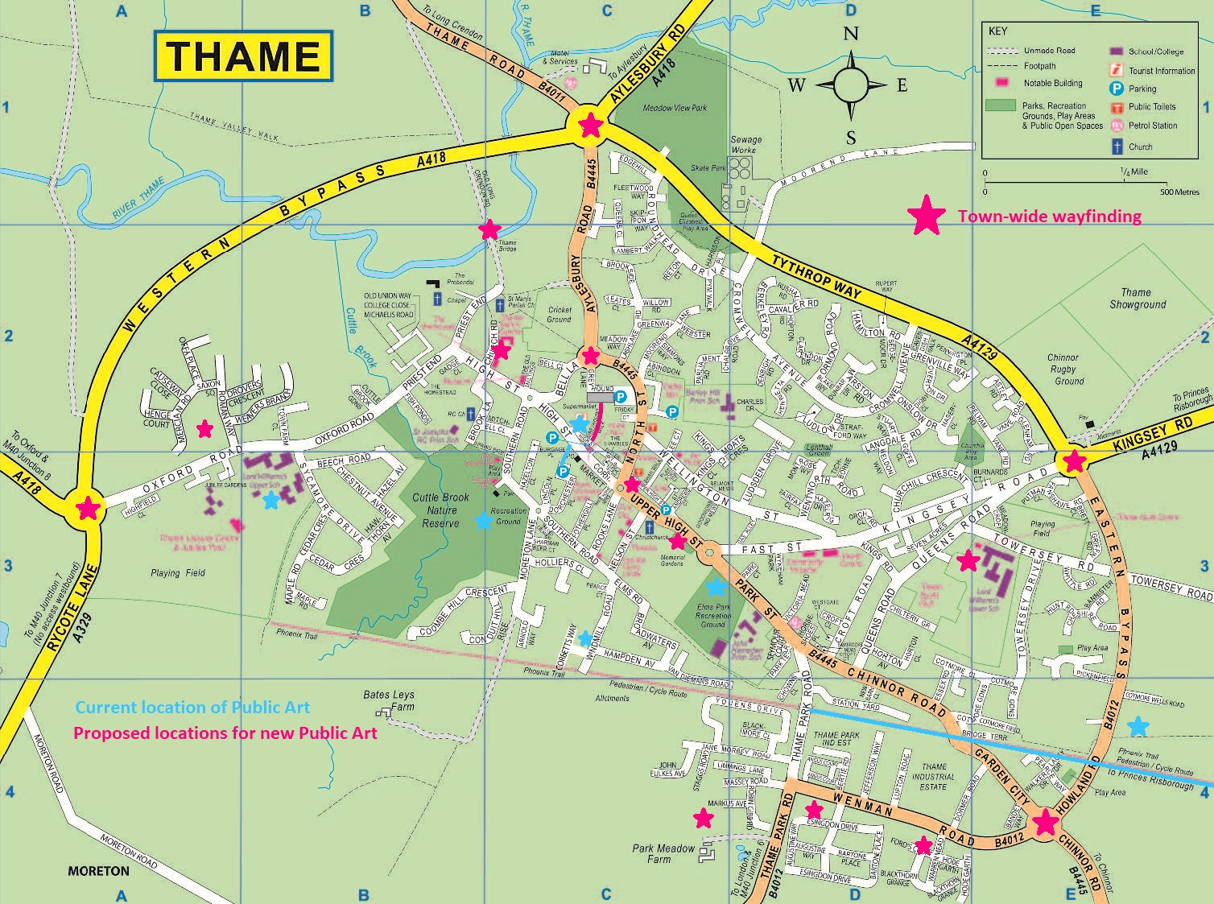

Priority | Idea | Proposed Partners
1 | Town-wide wayfinding project that both improves communication routes through the town as well as raising awareness of Thames Heritage. Included in this connecting all new estates into Thame, but also covering wayfinding throughout the rest of town (covering Lea Park). | Involve the whole community possibly through resident associations. Look at involving other community groups in locations that are relevant to them.
2 | Co-op Alleyway to Dorchester Place Car Park: Boost the profile of this space by making it more inviting to walk through, not just a gap between buildings. Making the alleyway more of a threshold that helps people to anticipate what is beyond the Alleyway – especially as a gateway to the Phoenix Trail.  Note: subject to agreement of landowners | Co-op, Newitts, Lord Williams School, Sharman Beer Court
3 | Marking the gateways into the town centre using the roundabouts located at Chinnor Road, Kingsey Road, Aylesbury Road, Oxford Road, to celebrate Thame’s identity as a Market Town.  Note: this project is subject to a detailed risk assessment and achieving planning permission. The project may prove not possible depending on the outcomes of these. | OCC. Possibly business located close to each roundabout being involved in sponsoring the artwork at their location.
4 | Greyhound Lane: Create something that is beautiful in its own right, but also serves as a frame from which community groups and artists could hang a temporary art display. Create a sense of busy vibrant community. Allows for more arts in the street.  Note: subject to agreement of landowners | Greyhound Lane owners; The Forge; Shop owners along Greyhound Lane. Waitrose management.
5 | Monteson Square: Meeting point of all directional signage boards in Thame: a place where these all come together and meet, in a central ‘meeting point’. Connect different elements of Thame together in one place to raise awareness of Thames Heritage and Thame today.
6 | Bridge on old Long Crendon Road: Make more of this area. Celebrate the connection of Tolkien’s short story to this location. Possibly improve access to the field for dog walkers. | Buckinghamshire County Council Bucks CC, Ox CC, Edwina Gibb, Tolkien Family
7 | Information Boards: purpose built information boards on each new estate. Designed to link to Wayfinding project. | Developers from each site
8 | The Elms: focus on artwork to educate about the Burgage plots in Thame. Potential to look at further piece of Art work in some of the gardens. To be followed up once progress has been made on the Sale of the land. | tbd

