PROMOTIONAL SIGNAGE IN THAME
Information Sheet

Thame Town Council (TTC) has various opportunities for displaying promotional signage around Thame. This is restricted to signage that promotes events being delivered in Thame and Moreton. Local charities, local businesses and visiting events can seek permission for positioning signage at set locations around town for this purpose, using the application form at the end of this document, in line with the Terms & Conditions outlined below.

Where the signage is being used to promote an event being delivered by a business a charge may be incurred as detailed in the application form.

Signage can be positioned at the following 10 locations:

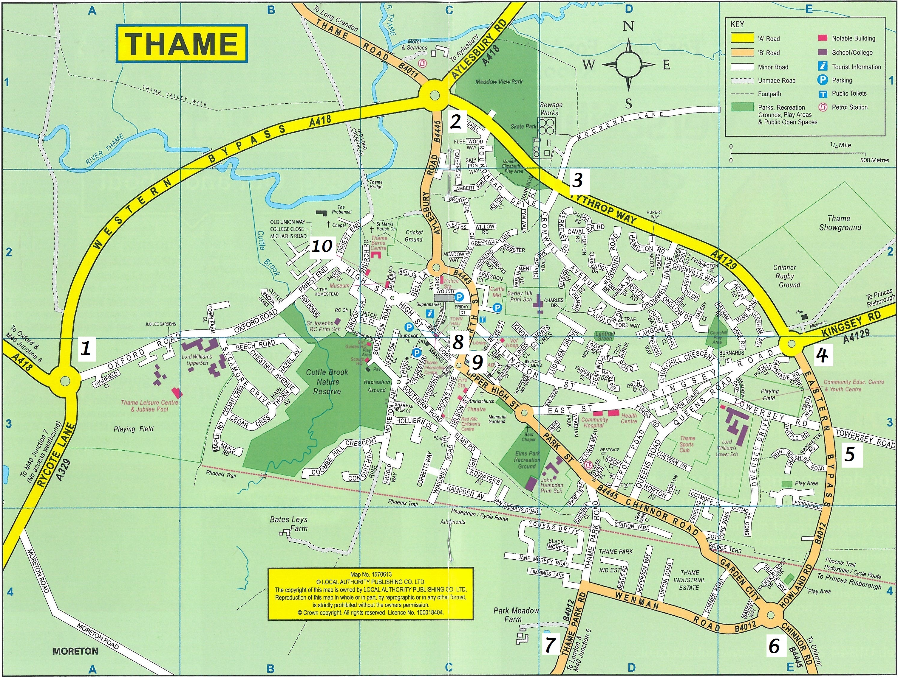
Note: Position 8: outside Town Hall. Position 9: Market House Railings. Position 10: Stribble Hills

NOTE:
TTC has responsibility for removing fly posting and monitoring event signage in Thame and the surrounding parish. Any sign which is posted without the Town Council’s prior consent will be removed and retained by the Council for a period of 14 days. Removed signs can be retrieved within this period by contacting the Town Council on 01844 212833. Signs which are not collected in this period will be destroyed.

Only signs promoting Thame or Moreton events can be displayed on the Town Entrance planter on a first come first serve basis.

Signs posted by the travelling community are subject to separate legislation.
Signage options available for Community Groups & Events
- Independent signs to be positioned in grass verges
Specification:
- Can be located at positions 1- 7 on map above
- No bigger than 100cm x 60cm in size
- Fixed securely to temporary posts inserted into the grass verge.
- Fixings must be provided by you

- Attachment of signs to Town entrance planters
Specification:
- Can be located at positions 1- 7 on map above (6 - Location Chinnor entrance is not in use at the moment)
- No bigger than landscape 100cm x 60cm size
- Fixed securely to planters using cable ties
- Fixings must be provided by you

- Feather flags
Specification:
- Can be located at positions 1-8 on map above (6 - Location Chinnor entrance is not in use at the moment)
- Bases provided at each location. Additional fixtures (poles) to be collected from and returned to Thame Town Hall
- You are responsible for providing the feather flags. Details of specifications for printing available from Cassie.Pinnells@thametowncouncil.gov.uk
- We recommend providing double sided feather flags as single sided may move in wind and hide details.

- Banners: Market House Railings
Specification:
- Can be located at position 9 on map above
- Restricted to a maximum of two community banners only
- Maximum dimension of banner allowed: 6ft x 3ft
- Must be fixed securely to railings using cable ties
- Fixings must be provided by you
- Banners to be put up after 10am on agreed start date and removed by 10am on agreed removal date

Stribble Hills Banners:
- Opportunites to display a banner at Stribble Hills are also available for community activities within the immediate vicinity i.e. St Mary’s Church, Barns Centre, River Thame. Permission may also be granted for specific high profile, town-wide events. For more information contact Cassie.Pinnells@thametowncouncil.gov.uk

Sponsorship Opportunities for Businesses

If you are a local business and you want to promote your business, Thame Town Council has the following sponsorship opportunities available:
- Millennium Planter signage
- Flower beds
- Town Gateway planters
- Floral standards.
APPLICATION TO DISPLAY PROMOTIONAL SIGNAGE IN THE PARISH OF THAME

Name of organisation

Address
Email
Telephone no.
Name of event
Date of event

 | Location (please tick) |  |  |  |  |  |  |  |  |  | Start date | Removal date
Signage option | 1 | 2 | 3 | 4 | 5 | 6 | 7 | 8 | 9 | 10 | Start date | Removal date
Grass verge

Town Entrance  Planters |  |  |  |  |  | N/A
Feather Flag |  |  |  |  |  | N/A
Market House - Railings
Stribble Hills *Terms apply

I have read and understand the Terms & Conditions (overleaf) regarding signage.

Thame Town Council regards your privacy as important and any personal information you give to use will be used in accordance with the law. Please read our privacy notice attached or at www.thametowncouncil.gov.uk/privacy

By signing the form, you are agreeing that Thame Town Council can hold and process your personal data, as provided on and with this Form.
Signature of Applicant: Date:

Please complete the above application form and return it to:
Thame Town Council, Town Hall, High Street, Thame OX9 3DP, marked for the attention of Jane Webster or send it by email to info@thametowncouncil.gov.uk

Terms & Conditions:
- Thame Town Council reserves the right to decide which signs may or may not be displayed within the parish at all times.
- Only Thame community groups or other community groups holding an event in Thame or Moreton, will be given permission to display signs. This will be subject to availability on a first come first served basis.
- Where the signage is being used to promote an event being delivered by a business a charge may apply as follows:
  - Details of current rates available on request
  - Charges are fixed to cover the full 2 week period
  - Pro-rata charges will only be available if it is not possible for signs to be displayed for the full 14 days of the booking, due to a prior booking
- With the exception of sponsorship which is subject to alternative terms and conditions, signage may be displayed a maximum of 14 days in advance of the event and must be removed within 3 days of the event taking place.
- Thame Town Council accepts no responsibility for signs displayed under this agreement. You are responsible for your signs at all times.
- All signage designs must be agreed in writing by Thame Town Council before being displayed.
- Signage must be positioned in a way that is sympathetic to grass cutting needs.
- No more than 10 signs can be displayed per event
- The owner of the sign must indemnify the Town Council against any claims arising from the placement of signs on the highway. In addition, they may be held liable for any action brought against them if there is an accident or damage due to the object being on the highway
- The Town Council will not permit signs which:
- cause a hazard or interfere with the visibility of motorists;
- obscure previously existing signage;
- are offensive or unsightly;
- are affixed to any tree;
- represent a danger to vehicles that might collide with it;
- are intended purely to advertise goods or services.
- Thame Town Council regards your privacy as important and any personnel information you give will be used in accordance with the law. Please read our privacy notice attached on page 5 or at www.thametowncouncil.gov.uk/privacy

Privacy Notice

When you contact us:
The information you provide (e.g. personal information such as name, address, email address, phone number, organisation) will be processed and stored to enable us to contact you and respond to your correspondence, provide information and/or access our facilities and services. Your personal information will not be shared or not be provided to any third party except where absolutely necessary and in conformance with the law.

The Council’s Right to Process Information:
General Data Protection Regulations Article 6 (1) (a) (b) and (e):
(a) Processing is with consent of the data subject or
- Processing is necessary for compliance with a legal obligation or
- Processing is necessary for the performance of a task carried out in the public interest (e.g. to progress a complaint) or in the exercise of official authority vested in the controller

Information Security:
Thame Town Council has a duty to ensure the security of personal data. We make sure that your information is protected from unauthorised access, loss, manipulation, falsification, destruction or unauthorised disclosure. This is done through normal building security, IT Security and password protection. We will only keep your data for the purpose it was collected for and only for as long as is necessary.

Children:
We will not process any data relating to a child (under 13) without the express parental/ guardian consent of the child concerned.

Data Protection Officer:
You have the right to contact our Data Protection Officer:
- to request access to the information we hold on you.
- to request the correction of the information we hold on you.
- to request the deletion of the information we hold on you.
- to object to the way that the information we hold on you has been used / processed.

Rights Related to Automated Decision Making and Profiling:
Thame Town Council does not use any form of automated decision making or the profiling of individual personal data.

Conclusion:
In accordance with the law, we only collect a limited amount of information about you that is necessary for correspondence, information and service provision. We do not use profiling, we do not sell or pass your data to third parties. We do not use your data for purposes other than those specified. We make sure your data is stored securely. We delete all information deemed to be no longer necessary. We constantly review our Privacy Policy to keep it up to date in protecting your data.

Contact:
You can contact our Data Protection Officer by any of the means at the head of this notice.

Complaints:
If you have a complaint regarding the way your personal data has been processed you should make the initial complaint to Thame Town Council’s Data Protection Officer.

If you are dissatisfied with the handling of your request or complaint, you have a right to appeal to the Information Commissioner. There is no charge for making an appeal. Contact details are: The Information Commissioner’s Office, Wycliffe House, Water Lane, Wilmslow, Cheshire, SK9 5AF. Telephone: 0303 123 1113 or email: casework@ico.org.uk

